PIRAQ3 Radar Processor for CP2

This document is a specification of the work required to produce a PIRAQ-based digital receiver/processor for the CP2 radar.

Project Scope

EOL will create a digital receiver for the CP2 dual-frequency radar based on the PIRAQ3D PCI data acquisition board. This system will replace obsolete electronics with a modern implementation supporting the aim of the Australia Bureau of Meteorology (BoM) to construct a research facility affording flexible treatment of radar data. In particular this Processor will provide timeseries data that can be processed in a variety of ways by a separate computing system, to be engineered by the BoM. However, to confirm Processor function, EOL will also need to create adequate test functionality on a remote system for preliminary testing at EOL prior to shipment to Australia.

Where possible existing hardware and software will be utilized to reduce development time and leverage previous NCAR investment. Such resources have been identified and are discussed below.

Existing Resources

The Processor shall be based on the software engineering and system architecture implemented in the RapidDOW (the “source project”), a six-channel radar system. The CP2 processor is structurally similar to the RapidDOW. It requires multiple PIRAQs, and it has timing requirements that are met by the EOL Timing Board. Each PIRAQ will be separately configured. It will use the PMAC for antenna control, for which mature software exists. A scheme for determining beam angles using interpolation has been developed and it has been tested extensively in the source project. This scheme is described in “Angle Interpolation in Piraq3 Radar Processor.doc”.

The RapidDOW Processor is described in “EOL PIRAQ3 Radar Processor.doc”. BRIEFLY, it is XP-based, with 3 host applications, and a DSP executable program that is loaded into each PIRAQ on startup. Data are DMA’d from the PIRAQ into a shared memory buffer. A host console application removes the data in units apropos of the processor (“beams”,“hits”), data packets consisting of an “info header” containing beam/hit-specific quantities, followed by range-gate data, either pulsepairs calculated in the PIRAQ, or I,Q timeseries. These are sent via localhost to other host applications. Data is transmitted via UDP broadcast to remote computers.

This fundamental structure will be carried forward, with modifications as required by CP2. That is, no new applications need to be developed. It provides effective functional separation that supports high throughput, configurability, and concurrent application execution.

Recent refinements to this scheme, resulting in the increased performance levels required by the project, are described in the section, “Current Status”. Test results confirming performance to the CP2 requirements are described.

CP2 Requirements

Signal Processing

The CP2 is a dual-frequency synchronized radar. It simultaneously transmits S- and X-band pulses. The S-band transmission scheme alternates H and V polarizations; the X-band transmits H and V simultaneously. To receive and process echoes, the Processor will utilize three hardware channels, two for X-band and one for S-band. Since the S-band H and V data are independent, logically there will be four channels requiring separate processing.

To achieve required dynamic range, each signal will be digitized by both PIRAQ channels; one channel’s input signal is attenuated. If the unattenuated channel input saturates, data from the attenuated channel is used and gain adjustments are applied to correct the data. Channel selection will be determined hit-by-hit by the PIRAQ executable and the appropriate data will be transferred across the PCI bus.

Throughput

Data is collected at (up to) 1000 Hz, over 1000 range gates, up to 1uSec in length. For research purposes, timeseries data is required, so that various pulsepair and data-quality-related calculations may be applied. To support required dynamic range, a floating-point I,Q pair is generated for each gate. With 3 PIRAQs, the sustained data throughput requirement is therefore 3M gates/sec, or ~25MB/sec if ~1MB of header-type data is added. This is 2-3x the maximum source project data rate.

CP2 system diagram

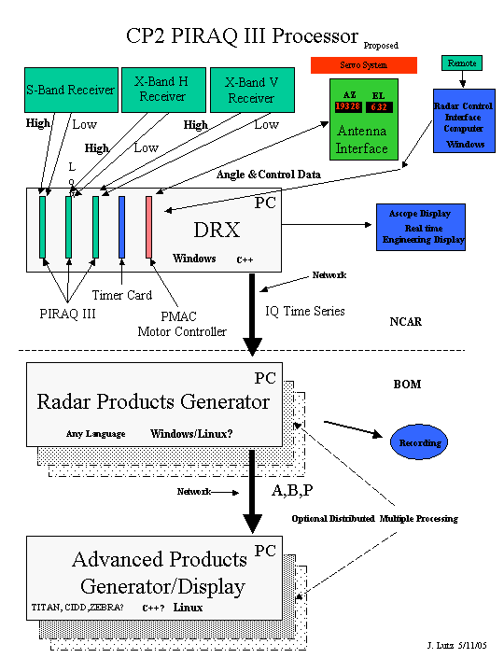

Current Status

The CP2 throughput requirement has been systematically tested by modifying the source project to transfer data at the required 25MB/sec, to determine if and where fundamental obstacles exist. This was done to test its suitability at the outset. The source project transfers pulsepairs calculated over beams. It has proven reliable at 125b/sec/board, or 375b/sec. If the current architecture were retained, the CP2 would transfer single-hit timeseries data packets, or 3000 PCI transactions/sec.

A test indicated that 3000/sec single-hit PCI transfers failed; time permitting this issue could be revisited for future development but for efficiency an alternative scheme has been investigated to combine multiple hits in the PIRAQ for transfer across the PCI bus. Simulating 8-hit packets, 375 64KB transfers occurred without error end-to-end for long periods of time. The network %utilization for one 1Gb/sec channel is ~25%, as expected. Between all processes a test of sequential packet numbers passed without significant error except for very brief bursts (<10 typically) on disruption (by vigorously dragging/dropping a high-priority graphic-intensive application). Errors ceased immediately on resuming “quiescent” operation.

CPU usage by processes declined significantly when the data scaling operation – applied to 6M data/sec – was moved from the console application to WinDSP, where compute-intensive tasks are done without conflicting with realtime transactions.

These results indicate stability at 25MB/sec sustained throughput.

A final udp-receive data integrity test on a remote system must be done to complete throughput testing. This is an Item in the Plan of Work.

Plan of Work by Item

Following is a list of tasks to accomplish to produce the CP2 Radar Processor, in order of completion; later items depend on earlier items being complete. All items in this section are required.

Project Development Infrastructure

Design and code on milan-office, test on NCAR Radar-DRX in lab: make efficient to develop in office, test in lab.

PIRAQ Executable

Timeseries: Redesign to process timeseries data only. Eliminate allocations and procedures related to pulsepair calculations to free up very fast on-chip memory to process larger timeseries data blocks. Design data flow within PIRAQ limitations: 64KB PCI Burst FIFO limits PCI DMA transfer size, and 64KB DSP-internal memory where compute-intensive tasks done at high speed.

Hit-combining: Rewrite PIRAQ-internal data transfer functions to support hit-consolidation.

Dynamic Range Extension: Design algorithm to process data from two piraq channels where one is attenuated (HI/LO). Combine data into one channel equivalent; match phase between two channels in combined data.

Test data: create test data sets, linear ramp and sinusoid. Test hit combination using data sets that stress boundary conditions.

Real Data: Set up signal generator in lab simulating two-channel scheme for extending dynamic range. Test PIRAQ Executable.

Header: Support to-be-determined changes to configuration files and the piraq header as required. Expect changes to be minor.

S-band Polarization Assignment: S-band transmission scheme is to alternate H/V polarization. Modify PIRAQ hardware to allow S-band polarization to be read. Assign value to header. Determine if fifo-half-full interrupt latency complicates assignment.

PMAC Direct Angle Read: If it is possible, develop an alternative to angle interpolation utilizing direct reads from the PMAC by individual PIRAQs; involves careful use of DMA by the PIRAQ. Determine uncertainty of measurement due to PCI bus transaction arbitration, etc. If accomplished, it would eliminate the use of WinDriver6, an expensive Windows driver generator that BoM may not want to use. This item is difficult to estimate, but is valuable because it creates EOL expertise in PCI direct data read between bus masters.

Console Application

Test Data: Use this application to test PIRAQ executable changes in data flow.

Test Pulse: Define and incorporate test-pulse function in configuration files, and piraq programming to set location and duration.

Angle Assignment: Determine method for accurately assigning angles to hits in multiple-hit scheme. Code and test interpolation through discontinuities; already designed. Requires live PMAC data.

WinDSP

Multiple-to-Single Hit Conversion: Receive localhost multiple-hit packets from console application. Create single-hit packets – as data scaling is done – out of the way of PCI bus transactions.

Channel-Specific Infrastructure: Create four data channels from three “hardware” channels: udp-send to unique ports for remote udp receive. Write four channels of data to separate FIFOs for diagnostic processing by Ascope.

S-band channel separation: Apply correct prf and other config’d parameters reflecting the functional independence of the H and V channels. Specific treatment to separate one hardware channel into two logical channels.

Ascope

Channel-Specific Data: display I and Q, I v Q, and fft by channel. Infrastructure for complete channel separation. GUI support for channel selection.

Reorient applications to single-channel operation

Reorient host applications and the piraq executable to single-channel operation. The source project processes two independent piraq channels. Define correct length parameters, data offsets, packet sizes, FIFO lengths, etc. Rewrite data handling to process one channel only.

Remote Test System: FC3

Before shipment to Australia the Processor requires testing for data integrity. BoM requirement is for a Linux-based Moments Generator. An FC3 system is available for this development work. As a resource this system is functional to check out and build an EOL Linux piraq3 project. It operates on the NCAR guest net.

Multi-channel udp receiver: Test data transmission /network integrity using udp-receive application on remote computer. Simultaneously receive and verify info header parameters and data from four channels. Source project contains a piraq udp-receive application. Port this simple XP application to FC3 test system; remove MFC functionality, try XP IDE (VC++) and build/FC3 build, test. Receive four independent data channels. GUI support.

Moments Generator: Mike Dixon has supplied a well-tested Linux project “lirp2Dsr” to input pulse data and calculate moments. This project will require development of an input method to Pulse Object for piraqx-headered single-channel timeseries data.

Real data: Use Moments Generator to test real data: compute power, set receiver gains, noise floor, etc. and confirm expected changes in computed data.

System

Integration: Resolve unforseen issues resulting from 8 applications on 3 platforms interacting.

BoM System: Select target system for BoM, install all hardware. Install software tools, components and application code. Test completely.

Documentation: Provide BoM with adequate documentation to do continuing engineering.

Optional Items

Transmit Power Measurement: Define and incorporate transmit power measurement. Affects PIRAQ Executable and possibly other applications. Will require PIRAQ hardware modifications, and probably additional hardware.

Ascope pulsepair calculations: using channel-separated timeseries data, compute ABP pulsepair data, and display power, velocity, NCP by channel.

Estimate

Item | Time to Complete (days)
Project Development Infrastructure: make efficient to develop in office, test in lab. | 4
PIRAQ Executable
Timeseries | 8
Dynamic Range Extension | 10
Test Data | 2
Hit combining | 3
Real Data | 3
Header | 1
S-band Polarization Assignment | 4
PMAC Direct Angle Read: note – difficult to estimate | 10
Console Application
Test Data | 2
Angle Assignment: if PMAC Direct Angle Read not feasible | 5
EOL Timer Programming for Klystron (S-band): requires further definition | 10
Reorient applications to single-channel operation
All applications | 5
WinDSP
Multiple-to-Single Hit Conversion | 3
Channel-Specific Infrastructure | 5
S-band channel separation, related configuration issues | 2
Ascope
Channel-Specific Data: timeseries only | 8
GUI Changes | 2
Remote Test System: FC3
Multi-channel udp receiver | 15
Moments Generator | 12
Real Data | 8
Total Required:
System
Integration | 10
BoM System | 10
Documentation | 10
TOTAL | 153
Optional
Transmit Power Measurement | 10
Ascope pulsepair calculations | 7
Total Required + Optional: | 170

Note as of 7-15-05 maybe 20 days of this time are used …

